

FINAL REPORT – Group 10 A

Team Members
- Anuj Kumar Agrawal
- Brijesh Kumar
- Girish Kumar
- Raman Rangaswamy
- Seema Malhotra
Git hub repo- https://github.com/aiml19/aiml

Your final report is also the milestone-2. It should contain all the 6 Sections mentioned in the project document. The report structure and brief requirements of each section is listed below.

- Summary of problem statement, data and findings

Every good abstract describes briefly what was intended at the outset, and summarizes findings and implications.

Summary of the Problem Statement –

Data –

Shape of the data

- No of columns = 4
- No of rows = 8500

Data Column Description

- Assignment group - This is the group to which the tickets has been assigned for resolution
- Caller - This is the user caller who reported the issue
- Description - This gives more detailed description of the tickets
- Short description - This is a short description of the issue/ problem (tickets)

Findings and implications.

IT Support Process :
- End users (composed of IT Users/ Business Users and Vendor and Supplier (if they have access to IT Support Portal) create IT incidents / tickets using IT Support Portal
- The tickets are automatically assigned to Service Desk.
- Service Desk resolves the L1/L2 tickets
- If Service Desk is unable to solve the tickets (L3 tickets), they assign the L3 tickets to Functional and IT Experts.
- Functional / IT Experts resolves the L3 tickets. If required, external vendor’s help is taken for L3 tickets resolution
- L3 tickets/ priority tickets can be directly assigned to Functional experts in case of urgency via phone calls/ e-mails etc.
Volumes being Handled :
- ~ 54% of L1/L2 tickets are handled and resolved by Service Desk
- ~56% of L3 tickets are handled and resolved by Functional/ IT Experts/ Vendors (as per requirements)
Time Spent:
- 15 min is being spent for SOP review for each incident
- Minimum ~25-30% of incidents needs to be reviewed for SOPs before ticket assignment
- Minimum of ~1 FTE effort needed “only “for incident assignment to L3 teams.
Others:
- Around ~25% of Incidents are wrongly assigned to functional teams
- Delay in ticket resolution impacting the business
- Additional FTEs required for L1/L2 support and correct assignment of tickets
- User dissatisfaction
- Under-utilization of resources because of non-value added activities
Objective:
- To reduce the ticket assignment time
- To reduce ticket resolution time
- To reduce wrong assignment of tickets
- To optimize the resources
e.g. Service Desk can utilize the time for ticket resolution instead of going through SOP and ticket assignment
ML/AI can work 24X7 through out the year (without worrying about corona )
Proposal :
To automate the ticket the process of ticket analysis and assignment to the right functional / IT expert groups (using Machine Learning / AI tool)

- Overview of the final process

Briefly describe your problem methodology. Include information about the salient features of your data, data pre-processing steps, the algorithms you used and how you combined techniques.

Problem methodology
The under depicted diagram depicts our approach to the problem –

For Pre-processing of the data we took a usual Approach of Data loading in Pandas , Missing value treatment and then extracting NLP features .
Post that our study follows 2 Tracks .
Track 1 – Gensim LDA Model
Track 2 – Using Existing groups
Further , both tracks use 2 models –
Model 1 – Sktlern Model
Model 2 – Keras Sequential
Finallly we processed the analysis to depict the best model

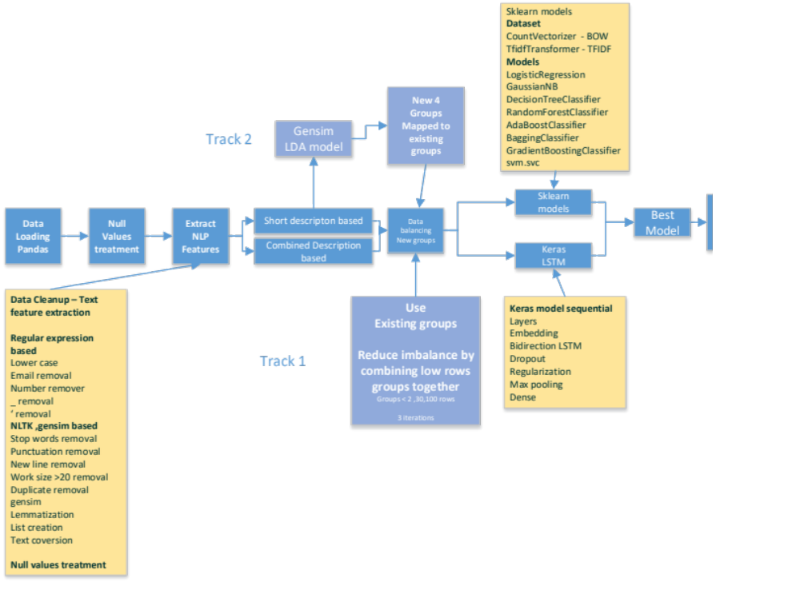
  - salient features of data,
Observations
- There are 74 assigmnment groups
- Group 0 seems to be the biggest accounting for about 45-50% of the total observations
- More than 50% of the groups seems to have only 1-2 observations
- 4 or 5 groups account for about 80% of the observations
Data is highly imbalanced based on Assignment Groups
There will not be a good learning/ Training for all the Assignment groups becuase of very less observation for many of the groups

  - Data pre-processing steps, the algorithms you used and how you combined techniques.
Data Pre-processing Steps-
      - Missing Value Treatment ( Dropping null Values )
      - Text Preprocessing
        - Converted the text to lower case
        - Removed digits, punctuation marks, new line , carriage return and unwanted spaces
        - Removed stop words (stop words are words which are filtered out before or after processing of natural language data. Though "stop words" usually refers to the most common words in a language, there is no single universal list of stop words)
        - Tokenization, Stemming and Lemmatization
      - Creating Dictionary of words

Algorithms Used & Combined –
- Topic Modeling and feature extraction
- Keras LSTM
- SktLearn Sequential
Table 1. Dataset Details

 |  |  | Total Tickets |  | Problem Categories |  |  | Multimodal
 |  |  |  |  |  |  |  | Tickets if any
 | Overall
 | Selected
 |  |  |  | Table 2. Model Details
 |  |  |  | Keras |  |  | SktLearn
 | Accuracy
 | Loss

- Step-by-step walk through the solution

Describe the steps you took to solve the problem. What did you find at each stage, and how did it inform the next steps? Build up to the final solution.

- Model evaluation

Describe the final model in detail. What was the objective, what parameters were prominent, and how did you evaluate the success of your models?

- Comparison to benchmark

How does your final solution compare to the benchmark you laid out at the outset? Did you improve on the benchmark? Why or why not?

- Visualizations

In addition to quantifying your model and the solution, please include all relevant visualizations that support the ideas/insights that you gleaned from the data.

  - GroupWise Ticket Visualization –
    - There are 74 assigmnment groups
    - Group 0 seems to be the biggest accounting for about 45-50% of the total observations
    - More than 50% of the groups seems to have only 1-2 observations
    - 4 or 5 groups account for about 80% of the observations
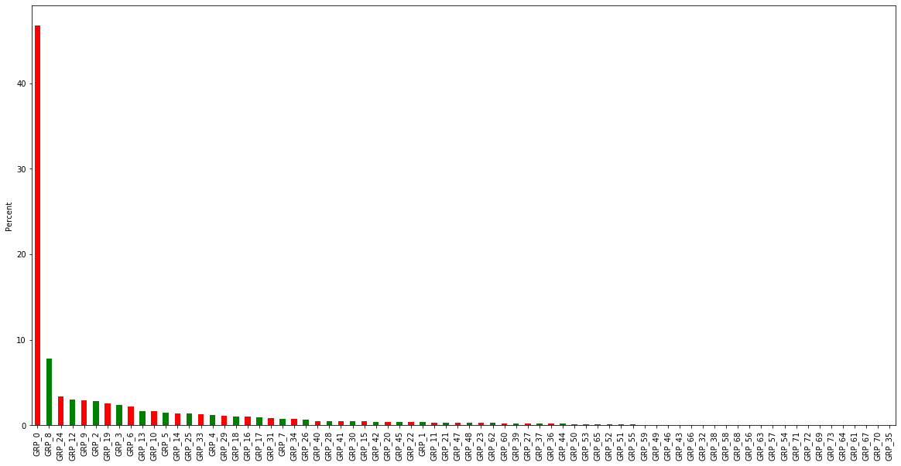
  - Visualisation to Generate Topics
If we look at the work cloud (we have done it for both Bag-of-words and TF-IDF). We can not only see the distinct group (provided by LDA) but also we can make good guess about the group call as well. e.g.
- topic 0: seems to be related to problems about background jobs, status, issues etc.
- topic 1 :seems to be related to general problems about user pcs (e.g. setup, services etc.)
- topic 2 :seems to be related to problems about communication problems (e.g. outlook, email, skype etc.)
- topic 3 :seem to be related to the problems arising out of applications (erp, crmm password reset locked etc.)
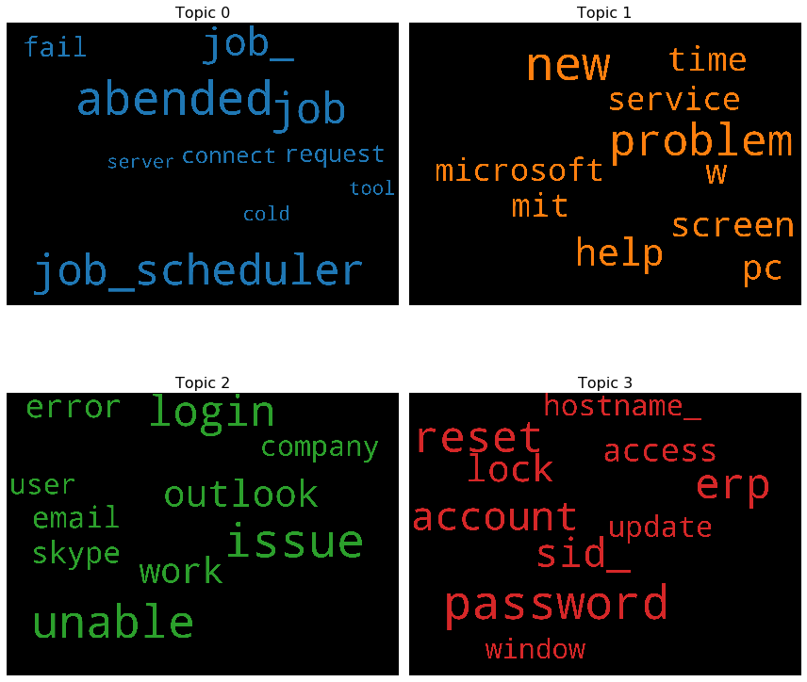

- Implications

How does your solution affect the problem in the domain or business? What recommendations would you make, and with what level of confidence?

- Limitations

What are the limitations of your solution? Where does your model fall short in the real world? What can you do to enhance the solution?

- Closing Reflections

What have you learned from the process? What you do differently next time?
- Often users are unaware of the exact problem or do not know what all details might be important for solving the problem and end up not specifying relevant information. For example, in a lot of IT support tickets the name of the operating system, application, version and other important contextual information are omitted. Without these information it may be di cult to drill down to the exact problem category and resolver group. Thus, we should augment the text data with context information and insights obtained from the data to create a better ticket which helps in improving the prediction of resolver group and problem category leading to faster ticket resolution.
- Our data contains a lot of non-English comments , a dictionary/NLP process incorporation of non-English words into AIML analysis will strengthen the solution
- An end-to-end system which can analyse image content in tickets, understand the nature of the problem indicated in the image and automatically suggest a resolution .Like a specific type of attachment, viz. screenshots, as this is the most common type of attachment, requiring human supervision, found in IT support tickets

